ServiMapp – Diagramas de Clases (Arquitectura Hexagonal)
Fecha: 26/12/2025
Iteración CD-5 (v1.0). Alcance: servimappers-service, fixed-business-service, notifications-service.

1. servimappers-service
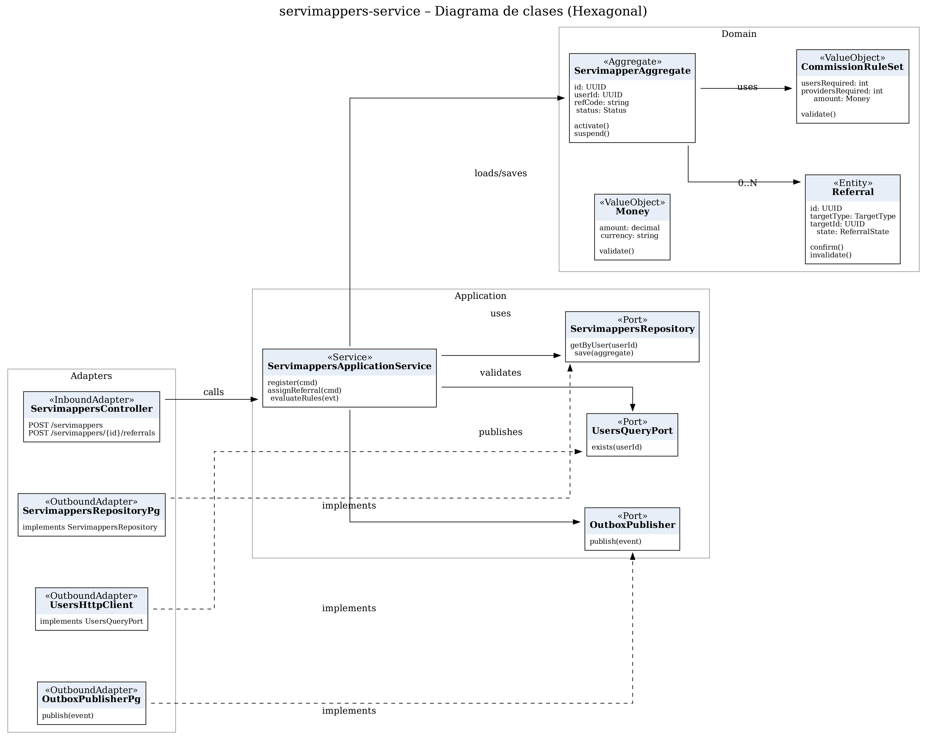

2. fixed-business-service
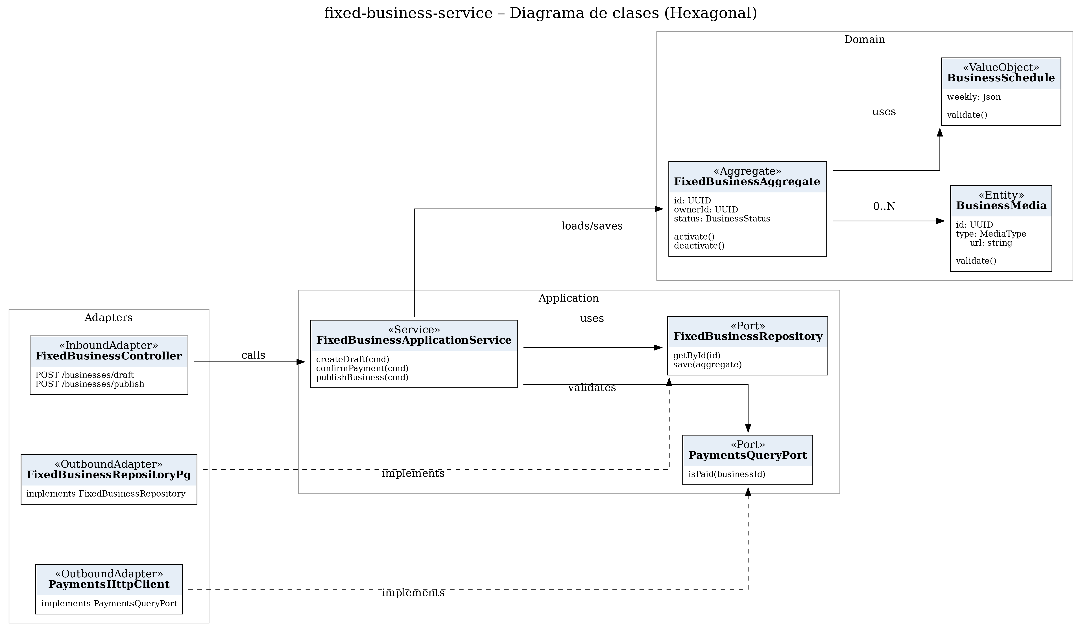

3. notifications-service
